3 The Methods

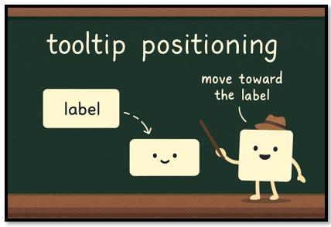

# The show_tip Method

**The Opening Line (method signature)**

Let’s start with the opening line of the method. You start with the keyword def, this means we are starting to write the method now, so pay attention. Next is the name, the name is asking what do I want this method to do. Print a name, open a page, show a tool tip. So, what am I doing in this method?

**def** show_tooltip

**The Parameter List**

The parameter list in a method is a bit different from what you will see in the parameter list of a function. In a function, the parameter list is asking questions. If the name is telling you, what the function wants to do, the parameter list is asking the object what it needs, in order to do it. But in a method, you will start with the word ‘self’ and self is one of the many objects that can be created from the recipe that is contained in the class. self just means, that there is an object out there that wants to be created, and it wants it done to itself, so self is explicitly stated so that each object, (or self) gets the exact recipe used on it.

The event is being passed into the parameter list, because it needs to know what an event is in order to preform some behavior that the tool tip will want to do. Just passing event in, download everything it needs to do any sort of event. It is like handing it a special spell book, and now it can start conjuring.

**The Method**

So, what is the body of the method doing? One of the things this tool tip wants to be able to do is to just show up. Which is a very important thing for a tool tip. So, it needs to create the window for it to sit in. But starting with an if statement protects the darn code from blowing up when you run it. Or you don’t want it to do that, it throws a lot of squiggly angry lines at you, put some really strange looking jargon in the terminal, and will just refuse to do anything until you fix it. So, yes in most cases exspecally if there is some real danger of screw up, you are going to want to throw in an if and have the program, just back out and return to you.

Ok, so once you get this window, how will it behave? Well it is set to Toplevel window, and doing this will make it look like a little floating window above the main project.

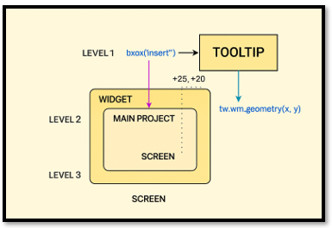

**Let’s break down the show_tip method**

def show_tip(self, event=None):

        if self.tip_window or not self.text:

            return

        x, y, _, cy = self.widget.bbox("insert")

x += self.widget.winfo_rootx() + 25

        y += self.widget.winfo_rooty() + cy + 20

        self.tip_window = tw = tk.Toplevel(self.widget)

        tw.wm_overrideredirect(True)

        tw.wm_geometry(f"+{x}+{y}")

        label = tk.Label(tw, text=self.text, background="#ffffe0", relief="solid", borderwidth=1)

        label.pack(ipadx=5, ipady=2)

We start with the if statement, if things are not right return. It is basically saying if a tooltip is already showing, or there is no text to show, do not do anything. It is a very basic gatekeeper for tooltips.

if self.tip_window or not self.text:

            return

The next line is positioning the widget next to the window. The little cy is math that is done behind the scene to determine how far below the cursor the tooltip should appear. Two lines below this line, you will see it is being further calculated.

**x, y, _, cy = self.widget.bbox("insert")**

This next line of text is used to horizontally position the tool tip so it appears in the right place on the screen — this is specifically being positioned a little to the right of the widget’s insertion point. The widget can be a button, a label or anything else you want to attach a tool tip to.

**x += self.widget.winfo_rootx() + 25**

This next line creates the actual tooltip window. We're calling it tip_window, and it's an instance of the Toplevel class from the tk library. That class gives our tooltip the ability to float above the main window—like a little popup that doesn’t have a title bar or frame. You import tk at the top of your code to access this magic.

**self.tip_window = tw = tk.Toplevel(self.widget)**

This next line of code is what turns your window into a tooltip window, if you did not add it, it would have a lot of unnecessary stuff attached to it. It removes, the tiltle bar, borders the minimize/maximize/close buttons and the resizing handles.

tw.wm_overrideredirect(True)

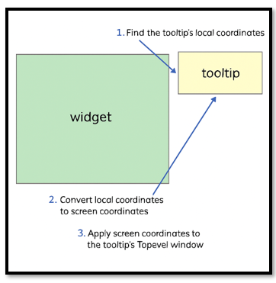

The next line is for positioning the tool tip window, and it will actually take the calculations that were given above, and use them to help position it self.

  tw.wm_geometry(f"+{x}+{y}")

We have already learned about the last two lines of the method in the last tutorial. All these two lines are doing is creating a label, and the line after it, is placing it on the window so we can see it by using pack.

label = tk.Label(tw, text=self.text, background="#ffffe0", relief="solid", borderwidth=1)

        label.pack(ipadx=5, ipady=2)

# The hide_tip Method

This one is really easy, it is basically saying, if there is a tooltip window open, destroy it, and then the tip_window should be None (gone)

**def** hide_tip(self, event=None):

        if self.tip_window:

            self.tip_window.destroy()

            self.tip_window = None